Name:
Instructor:
Course Title:
Date:

INTEGRATED MARKETING COMMUNICATION APPROACHES
A Comparison and Contrast of Two Companies
Description of Amazon and Walmart
Amazon and Walmart Inc. are the leading retail outlets in the United States. Walmart was established in 1962 and based its business on brick-and-mortar stores located in many neighbors across the US. Walmart also has many product categories and it is broadly considered as a one-stop shop. Amazon, on the other hand, was established in mid-1994 as an e-commerce retail chain. Amazon tapped into the emergence of digital communication and utilized the internet space to curve a retail path. The increased access to digital platforms changed how consumers shopped and Amazon saw a retail opportunity by extending multiple shopping and retail opportunities to digital consumers. Credible sources speculate that in the next decade, Walmart stock will supersede Amazon because of a variety of reasons (Buckley et al. 1). First, integrating its brick-and-mortar stores with an e-commerce platform is a positive strategy for Walmart Inc. Its market entry in China and India is also a sound strategy given the China’s booming middle class (Buckley et al. 2). Walmart has a robust balance sheet and strong cash flows which makes it a competitive feat in the digital retail space. Nevertheless, it should be noted that the success of both retail outlets Walmart and Amazon, has relied majorly on a set of integrated marketing and advertising approaches. The focus of this analysis is to comparatively evaluate the use of integrated marketing communication approaches for the two companies.
Description of their Products and Services
Amazon and Walmart have similar product categories but definitely discrete services in terms of customer and shopping experiences. Both firms retail consumer products namely; clothing, food, toys, building materials, household products, cosmetics, and gardening tools. However, the only difference is that while Amazon offers an ever-expanding product selection and a convenient shopping experience, Walmart is reputable for its low costs and broad physical retail stores. Similarly, Amazon relies on a large footprint of retail outlets to market its products and services. This means that it liaises with other businesses to market a large selection of products and this is partly a business-to-business B2B retail approach. Although targeting individual consumers and buyers, most of Amazon products are sourced from third parties and Amazon offers a digital space through which such enterprises can market and advertise. Walmart, on the other hand, sources products from suppliers and distributors and displays these products on the shelves. Walmart illustrates a dichotomized approach to the retail industry by leveraging the brick-and-mortar strategy to target and appease the buyers. Walmart has strong supply chains and widespread warehouses to store inventory.
Target Markets
Amazon Target Market
Amazon seeks to target a demographic that does not incur house bills and mortgages and which is tech savvy; the American teenagers. Amazon has rolled out a new digital service that enables teenagers and young adults to utilize their logins to access its affiliated e-commerce platforms. The target is on teenagers aged 13-years to 17-years old who are the generation Z and the largest demographic by size, and will someday be the largest in their spending power (Picchi, 2017). However, it has set a limitation for parents to approve purchases and to set spending limits. Amazon recognizes that teenagers and young adults are the largest demographics and feature unlimited shopping habits (Picchi, 2). Being the largest spenders, this demographic represents a potential target market for consumer products such as; DVDs, kindle, books, mobile phones, gaming consoles, clothing, jewelry, and gardening tools. Other than narrowing its target approach and market focus on American teenagers and young adults, Amazon also keeps the retail door open to other population groups including; older adults, seniors, and the youth in general (Primento Digital 25).
Walmart Target Market
The cross-sectional analysis of Walmart audience and consumers reflects middle-income earners and consumer groups that are just below the middle-class. Walmart low-cost approach targets people who are not wealthy, or not at all rich. This consumer group includes people in public assistance, those living below the poverty line, buyers who do not receive financial assistance from the paycheck, and people just above the poverty line. Consumers considered as the middle class or just above the middle class form a special target market for Walmart. It is important to establish that Walmart’s ability to integrate a collection of low-cost marketing slogans makes it possible to seize this particular target market. As will be discussed in later sections of this paper, Walmart promotion has a variety of slogans which include; Lowest Price, Live better & Save Money, Every day Low Prices, and Affordable Commodities. The cost-centric approach by Walmart makes the retailer a darling to most consumers and buyers, approximately 95% of the US population and demographics.
The Concept of Integrated Marketing Communications
. The approach carefully links together all forms of messages and communications with the assumption that the sum is greater than the parts. While promotion is one of the marketing mixes, it has its individual mix of marketing and advertisements. It is important to note that in integrated marketing communication, the concept works best when it goes beyond the basic level of communication (Chitty et al. 11). As a result, this communication is optimal when other forms of integration are tapped including vertical, horizontal, external, internal, and data integration. Credible sources further stipulate that IMC involves the process of creating a unified mix and a seamless customer experience for buyers to interact with the enterprise or brand (Chitty et al. 23). This concept seeks to blend all the different aspects of marketing; direct marketing, sales promotion, advertising, social media, public relations, and advertising into one single marketing funnel.
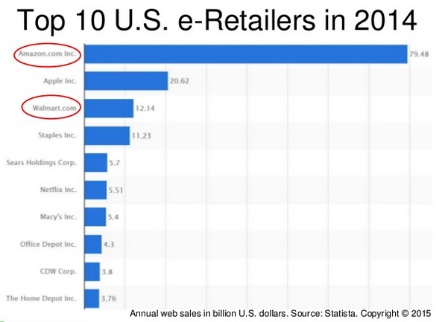
[Summit, 2015. Amazon and Walmart: Affiliate Marketing. The Slide Share]
Amazon Digital Marketing Approaches
Amazon has optimized on differentiation, positioning, and targeting to create a compelling marketing strategy. To successfully differentiate itself, Amazon acquired multiple e-commerce start-ups and technology companies. The acquired start-ups include Zappos, IMBD, Jungles, Audio.com, and Woot to optimize the existing technologies at low-cost and to leverage the existing digital technology. The goal of these acquisitions was to create a high-value for the existing customers by using the emerging digital technologies at a low-cost (Primento Digital 42).
Another than differentiation to optimize technology and deliver customer value, Amazon realizes that building a strong distribution strategy is pertinent to their success. It also recognizes that customers value the quick delivery of products they order. This is where its extensive distribution strategy through convenient stores comes in. As at 2017, Amazon had over fifty-five distribution and convenient stores that exceeded 45 million square feet (Narayan 25). The availability of strong and compelling distribution outlets enables Amazon to create a trust in customers by offering timely deliveries and in the process achieve brand equity.
Additionally, Amazon uses the product mix to create trust and deliver value. It uses product diversification to capture a variety of customers and clients. The huge product base includes; DVDs, kindle, books, mobile phones, gaming consoles, clothing, jewelry, and gardening tools. Under the promotion, Amazon mainly uses the digital capabilities to expand its market outreach (Narayan 43). In India and China, Amazon relies on the word of mouth which directs potential customers to its site. The company also relies on intra-promotions with other smaller digital brands to generate traffic and sales. This analysis supports that Amazon has relied exclusively on the marketing mix and integrated marketing communications. However, its sole approach is digital marketing, generation of traffic, and creating compelling brand equity in the digital space.

Brand Management, Buyer Behavior, and Advertising at Amazon
Brand management is pinned on the ability to build a compelling brand around quality, fast-deliveries, credible products, and a strong customer experience. Amazon has over the years optimized in the digital space to connect with customers, identify distributors [or convenient stores], and offer low-cost products based on industry dynamics. As a result, Amazon buyer behavior is, therefore, shaped on convenient shopping through online ordering and deliveries (Narayan 16). Buyers also see Amazon as a compelling digital brand due to its revamped marketing and advertising in freely-available, virtual digital spaces. As part of its advertising, Amazon has relied on cloud services by pushing investments in cloud and new data centers. Amazon believes that digital advertising is a big business and the source of its most trusted customers. Such an advertising digital approach enables the retail giant to remain anchored.
Walmart Integrated Traditional Marketing Approach
Walmart is noted to utilize a robust marketing mix. The retail giant recognizes that the prices of a product determine its sustainability and future profitability. As a result, the retailer has perfected its pricing strategy and positioning in a number of ways. First, it uses customer-friendly prices and optimizes on bulk sales as opposed to overpricing commodities. Walmart relies on excellent procurement strategies and works with trusted supply chain distributors to cut procurement costs to keep the overall prices low (Russell 33). Its product diversification also ensures that the complementary commodities and products can push the prices of other products up. And universal barcoding and SKU keep operations lean and leads to low prices.
Walmart further relies on traditional promotion and marketing to create brand equity. The retailer runs different promotions and discounts across all seasons. Walmart stores are also accustomed to using attractive slogans that keep prices low. These slogans include; Lowest Price, Live better & Save Money, Everyday Low Prices, and Affordable Commodities. The cost-centric approach by Walmart makes the retailer a darling to the consumers and buyers (Russel 43). Place as a marketing mix has also been optimized to contribute to Walmart’s success. For instance, the store has well-planned strategic physical stores that enable retailers to collect orders and distribute to customers. Recently, Walmart invested in a robust e-commerce platform to enable buyers to order products without visiting a physical store. Similarly, an advanced ICT system was implemented to enable the retailers to trace products and supplies whether on the shelves or in transit (CFI Education Inc. 2). Finally, Walmart has a fleet of distribution trucks to facilitate door-to-door supplies.
Differentiation and branding of multiple Walmart stores have enabled the retailer to target and access multiple markets. Differentiation has generated multiple retail outlets including; Walmart Express Stores, Walmart Supercenters, Walmart Discount Stores, and Neighborhood Markets. The rapid differentiation enables Walmart to access different markets, target discrete consumer bases, and in the process achieve brand equity and positioning. Robust geographical placements, especially in Europe and the United States, enable Walmart to be strategically located in targeting different consumers. Collectively, this comparative analysis of Walmart and Amazon integrated marketing communication supports that Walmart physical approach has achieved a strong brand positioning and in the process enabled the company record billions of sales and revenues since inception in 1982.
Walmart Brand Management, Buyer Behavior, and Advertising
Walmart brand management is built on the understanding that effective price positioning is key to creating demand. The retailer knows how to position and price based on the financial needs and incomes of the target demographics. Walmart brand management also appreciates the fact that effective supply chains are instrumental in creating value and passing cost savings to the consumers. Part of brand management is to utilize regular promotions to instill confidence and trust to customers particularly regarding warranties and return policies. (CFI Education Inc. 3). As a result, the above brand management initiatives enable Walmart to shape buyer behavior around aspects such as; cost-savings, store accessibility, guaranteed returns and refunds, trust and loyalty. Similarly, Walmart has accessible convenient stores where customer complaints are received and addressed in a timely fashion.
As part of advertising, it is vital to establish that Walmart relies on traditional advertising until very recently when it adopted an e-commerce approach. Walmart utilizes traditional advertising funnels including; magazine ads, newspaper releases, billboard, radio, and TV advertising (CFI Education Inc. 1). Additionally, conspicuously branded Walmart trucks provide the much-needed visibility to consumers acting as a compelling marketing and outreach approach. The strategic distribution of Walmart physical retail shops and convenient stores offers Walmart the much-needed visibility and access to physical consumers including households. It is, therefore, important to establish that Walmart's approach to marketing and advertising meets most of the metrics established in the integrated marketing communication. The retail giant optimizes the marketing mix [price, product, promotion, & place] in multiple ways as discussed and evaluated above.
A Comparative Analysis of Walmart and Amazon Integrated Marketing
It is crucial to note that both Walmart and Amazon bear discrete differences and discrepancies which in turn influences and informs their marketing approaches. The first difference is that Walmart began as a physical store and later added an e-commerce strategy in recent times. Amazon began as an e-commerce platform with a sole focus on business-to-business B2B approach and strategy. Walmart offers over four million in-store product categories that range from clothing, toys, electronic products, and a wide-spectrum of consumer commodities. Amazon offers buyers over 260 million products that fit into different product categories. It also adds more than 5,000 products every day owing to its business-to-business capabilities with distributors and retailers online. While Walmart does not feature any membership fee for online purchases, Amazon charges prime membership fees on monthly and annual purchases.
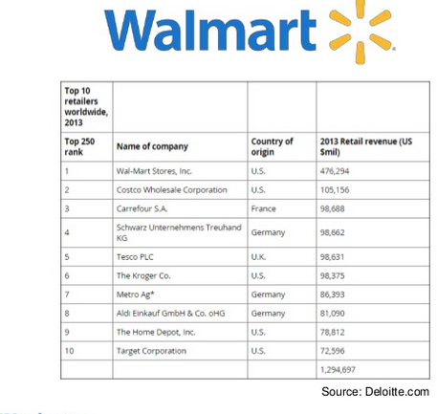

When examining distribution models, Walmart offers free deliveries for shopping carts exceeding $35 and Amazon prime membership status enable consumers to enjoy free deliveries, same day, and in other two purchases. Walmart has over 11,000 stores distributed across 27 countries globally. Amazon has limited physical retail stores but its digital presence permits buyers from over 180 nations to make orders and receive deliveries. Another major discrepancy is that Walmart has cheaper, affordable products except in the Food and Beverage section. Amazon has significantly affordable food and beverage products but slightly expensive in other product categories. Finally, Walmart recorded a $14 billion in revenues during the 2016 financial year while Amazon recorded $2.4 billion in the same fiscal year. However, e-commerce growth is considered higher than in-store purchases and hence the future of Amazon is seen as promising in the long-term. Based on the above comparative analysis, it is evident that Walmart optimizes on broader approaches to marketing and advertising. Since inception in 1982, it has optimized on traditional marketing mixes and presently has an e-commerce platform to keep pace with changing retail market dynamics. Amazon has tapped on digital media to curve a retail channel and be a market leader in the digital space.
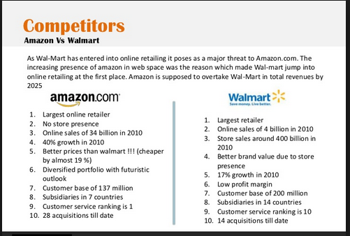

Further Analysis of Walmart and Amazon Integrated Marketing
The above analysis agrees that the integrated marketing communication is an instrumental model for most companies. The integrated marketing communication refers to the combination of multiple marketing and advertising approaches to creating a combined model. And while IMC refers to a collection of marketing aspects, at its most basic level, it goes beyond basic marketing communication and encompasses vertical, horizontal, internal, external, and data integration. To achieve this, Amazon has differentiated its outreach and marketing through the acquisition of compelling digital start-ups to optimize on the digital technology in creating a profitable online retail. Amazon as a parent company has other smaller digital brands, and they include; Amazon Instant Video, Amazon Cloud Services, Amazon Cloud Player, Amazon App Store, and Web Services. To successfully differentiate itself, Amazon further acquired multiple e-commerce start-ups and technology companies (Narayan 5). The acquired start-ups include Zappos, IMBD, Jungles, Audio.com, and Woot to optimize the existing technologies at low-cost and to leverage the existing digital technology. It is, therefore, conclusive to note that Amazon digital marketing and presence is built on constant diversification and differentiation in addressing the discrete market needs and changing industry dynamics.
Walmart is a leading retail giant with over 11,000 physical stores in over 27 countries. Walmart retail success is pinned on the ability to establish strategic store placements, optimize on cheap and effective supply chains, and affordable cost-centric approaches. Walmart has also tapped into convenient stores and distribution outlets to offer fast, accessible, and flexible order and deliveries (Jameson 13). The research further identifies that Walmart expansion strategy into China and India is pinned on the word of mouth. Its integrated marketing communication relies on a variety of approaches. First, under promotion, Walmart pricing structure is anchored on cheap and affordable products which urge well with 95% of middle to low-income households. Under place, Walmart leverages strategic physical store placements in every neighborhood to bolster accessibility and fast deliveries. The retail giant further optimizes product diversification to address the different needs of most consumers. Its product diversification also ensures that the complementary commodities and products can push the prices of other products up. And universal barcoding and SKU keep operations lean and leads to low prices (Jameson 52).

Conclusion
Overall, this analysis recognizes and supports that the Walmart Inc. integrated supply chain is superior, optimal and flexible than Amazon for a variety of reasons. First, it combines its brick-and-mortar approach with an e-commerce strategy. The ability to believe and trust in long-term earnings, combined with service and operational excellence to deliver lasting value. Its entry in China and Indian through vertical and horizontal integration will guarantee success as the middle of these markets boom. Robust cash flows and strong balance sheets as illustrated in its $14 billion revenues will ensure the retailer provides low-cost capitals and expenditures to support long-term growth (Buckley et al., 1). Finally, the underpriced Walmart stocks will consequently provide value to stakeholders. A comparative econometric analysis shows that the market is desperately undermining Walmart's value. Also, digital disruptions are likely to hurt Amazon's digital presence, create unnecessary competition, raise costs, and impair its digital autonomy. Such changes render Walmart an ideal retailer given its all-encompassing integrated marketing, better positioning, and target demographics.

Works Cited
Buckley, C, DeFina, P, and Root, L. Walmart vs. Amazon: Economist 2016 Investment Case Analysis. Shidler College of Business. 2016. Pg. 1 – Pg. 19.
CFI Education Inc. The Walmart Marketing Mix. The Corporate Finance Institute. (2018). The CFI Education Official.
Chitty, William, Nigel Barker, Michael Valos, and Terence A. Shimp. Integrated Marketing Communications. South Melbourne, Vic: Cengage Learning, 2011. Print.
Jameson, Greg. Amazon's Dirty Little Secrets: How to Use the Power of Others to Market and Sell for You. , 2015. Internet resource.
Narayan, N. The Brand Management Study of Amazon. The Slide Share Official. 2011. Pg. 1 – Pg.54.
Picchi, A. Amazon Eyes a new Target: American Teenagers with Higher Spending. The CBS News: Money Watch. 2017. Source https://www.cbsnews.com/news/amazon-eyes-a-new-audience-teenagers-with-spending-money/
Primento Digital. Summary: Amazon.com. Get Big Fast - Robert Spector: Inside the Revolutionary Business Model That Changed the World. United States: Primento Digital, 2013. Internet resource.
Russell, Edward. The Fundamentals of Marketing Communication. Lausanne: AVA Publishing SA, 2010. Print.
Summit, A. Amazon and Walmart: Affiliate Marketing to Learn. The Slide Share Official. 2015. Source https://www.slideshare.net/affsum/amazon-vs-walmart-affiliate-marketing-lessons-to-learn

